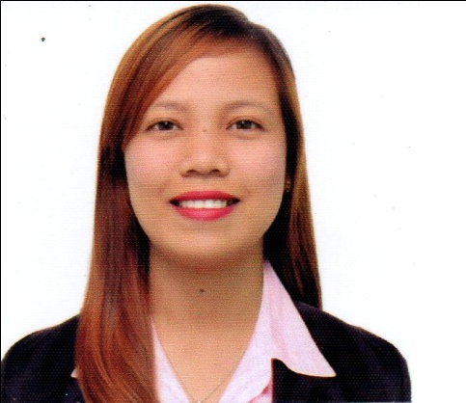**AMIRA H. VILLETA**

Zone 2, Tambo

Pamplona, Camarines Sur

(0917) 533 0628

[**amiravilleta@yahoo.com.ph**](mailto:amiravilleta@yahoo.com.ph)

**Objective**: To obtain a full time position in your company that offers professional working

environment and enables me to grow while meeting the company’s goal.

_____________________________________________________________________________________

**SKILLS AND ABILITIES**

* Computer Literate-Familiarity with Microsoft Word, PowerPoint, and Excel
* Enthusiastic, quick to learn with good interpersonal and organizational skills
* Able to work independently with minimum supervision
* Have a high sense of responsibility
* Has ardent willingness to learn and explore new things

**EDUCATION:**

TERTIARY **ATENEO DE NAGA UNIVERSITY**

AB BSE Major in Filipino

October 2014

SECONDARY **LYCEO DE PASACAO**

Sta. Rosa Del Norte, Pasacao Camarines Sur

2005-2009

**TRAINING/ WORKSHOP ATTENDED:**

* Seminar- Workshop on Visualization Techniques and Media (July 12-13 2014)
* Seminar- Workshop on KPUP (Knowledge, Process, Understanding, Product/Performance)
* OJT- Camarines Sur National High School (June-October 2014)

**REFERENCES:**

**MRS. EVELYN E. BRENDIA**

Camarines Sur National High School

Practicum Cooperating Teacher

(0915) 135 6693

**MRS. JEANETTE NAVAL**

Instructor

Practice Teaching

Ateneo De Naga University

**MR. ARNULFO AARON REGANIT**

DEAN

College of Education

Ateneo De Naga University